Project Development Phase
Model Performance Test
Date | 2 October 2026
Team ID | SWTID-2026-9615
Project Name | Streamlining IT Procurement: Automating Standard Laptop Orders with Flow Designer
Maximum Marks | Not specified in source document

Model Performance Testing: Project team shall fill the following information in model performance testing template.
S.No. | Parameter | Values | Screenshot
1 | Model Summary | ServiceNow Flow Designer workflow for standard laptop procurement. The flow creates a Catalog Task after approval and assigns it to the Hardware group. | 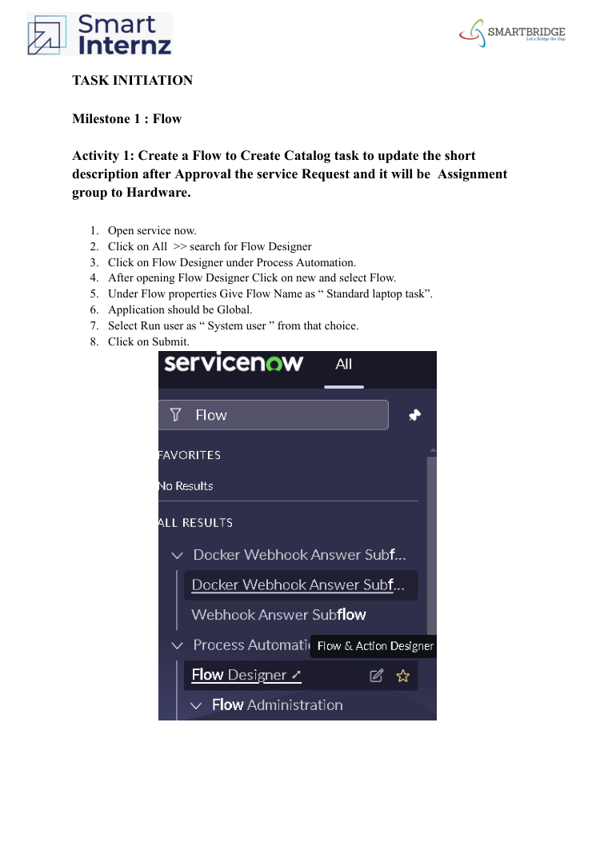
2 | Accuracy | Training Accuracy: Not applicable / not provided in source.  Validation Accuracy: Not applicable / not provided in source. | 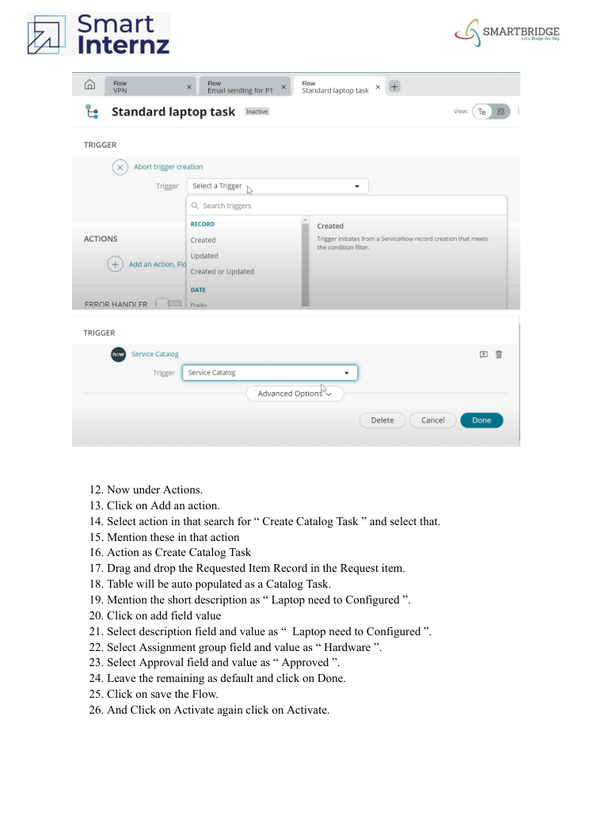
3 | Fine Tunning Result (if Done) | Not applicable / not provided. Documented implementation includes Flow creation, Service Catalog assignment, ordering, approval, and verification of the Catalog Task. | 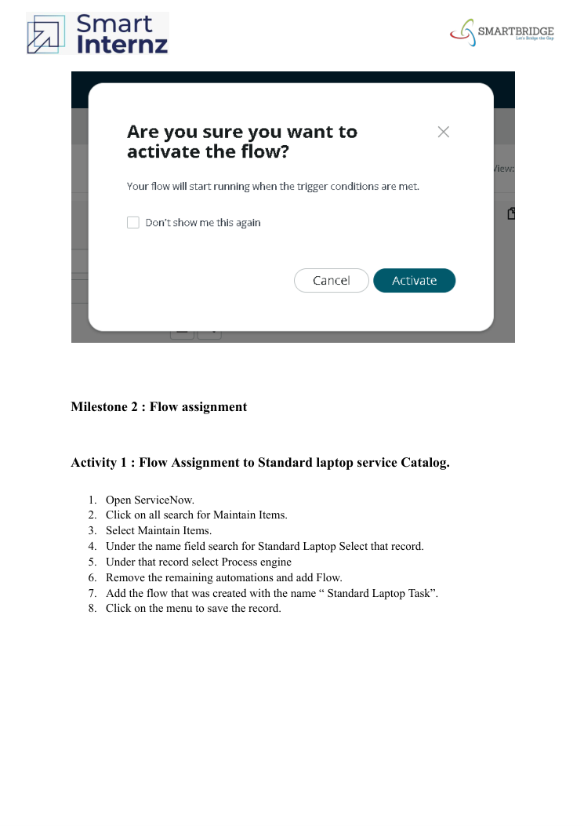

Documented Workflow Details
- Flow Name: Standard laptop task; Application: Global; Run user: System user.
- Trigger: Service Catalog.
- Action: Create Catalog Task using the Requested Item Record.
- Short description and description: “Laptop need to Configured”.
- Assignment group: Hardware; Approval: Approved.
- The flow is saved and activated, then assigned to the Standard Laptop service catalog item.
- UAT verification: place the Standard Laptop order, approve the request, open the Requested Item, and verify the Catalog Task short description and assigned group.

